***Name: Mohmmad Hussain***

***Assignment***

***Module -1: Understanding of Hardware and Its Components***

Section 1: Multiple Choice

1. Which of the following is NOT a component of the CPU?

1. ALU

2. RAM

3. CU

4. 1 and 3 both

Answer: 2) RAM

2. What is the function of RAM in a computer?

Answer: The main function of RAM is to load all in a computer, and store active data and program that we are entered and in RAM data is volatile, means it is lost when the computer is turned off

3. Which of the following is a primary storage device?

1. HDD

2. SSD

3. SD card

4. 1 and 2 both

Answer : 4) 1 and 2 both

4. What is the purpose of a GPU?

GPU stands for Graphics Processing Unit.

Its main purpose is to process and display graphics (images, videos, animations, 3D models) on the screen.

It works with the CPU but is specialized for graphics tasks.

Section 2: True or False

5. True or False: The motherboard is the main circuit board of a computer where other components are attached.

Answer: TRUE, Because It connects and allows communication between: CPU, RAM, Storage devices (HDD, SSD), GPU, Power supply, Input/Output ports and peripherals It acts like the central hub

6. True or False: A UPS (Uninterruptible Power Supply) is a hardware device that provides emergency power to a load when the input power source fails.

Answer: True

7. True or False: An expansion card is a circuit board that enhances the functionality of a component.

Answer: True

Section 3: Short Answer

8. Explain the difference between HDD and SSD.

Answer:

|  |  |
| --- | --- |
| HDD | SDD |
| 1. It speed is slow | 1. It speed is high |
| 2. low cost | 2. high cost |
| 3. it consume more power consumption | 3. it consume less power consumption |
| 4. less reliable | 4. more reliable |
| 5. more CPU power  6. large size | 5. less CPU power  6. short size |

9. Describe the function of BIOS in a computer system.

Answer: BIOS = Basic Input/Output System. Location: It is stored on a ROM/Flash memory chip on the motherboard.

Functions of BIOS:

1. Power-On Self-Test (POST): When the computer is switched on, BIOS checks if the essential hardware (CPU, RAM, keyboard, display, etc.) is working properly.

2. Boot Loader Function: BIOS looks for a bootable device (hard disk, SSD, USB, CD/DVD). It loads the bootloader/Operating System into RAM to start the computer.

3. Hardware Initialization: Initializes and prepares hardware components (keyboard, mouse, hard disk, monitor, etc.)

4. System Settings (CMOS Setup): date and time,

10. List and briefly explain three input devices commonly used with computers.

Answer:

1. Keyboard – Used to enter text, numbers, and commands into the computer.

2. Mouse – A pointing device used to control the cursor, select, drag, and drop objects on the screen.

3. Scanner – Captures images or documents and converts them into digital form for storage and editing.

Section 4 Practical Application

11. Identify and label the following components on a diagram of a motherboard:

● CPU

● RAM slots

● SATA connectors

● PCI-E slot 12.

Answer:

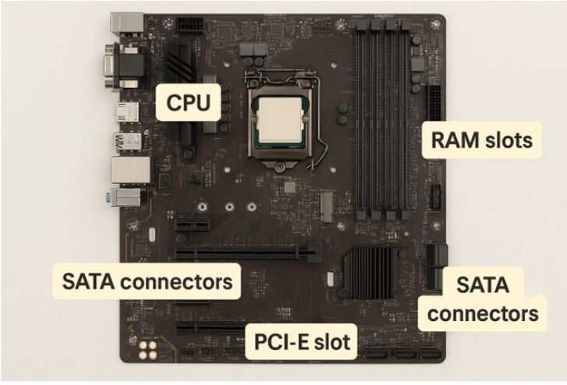

12. Demonstrate how to install a RAM module into a computer.

Answer: Steps to Install RAM Module:

1. Power Off and Unplug the Computer

-> Disconnect the power cable and all peripherals (keyboard, mouse, etc.).

2. Open the Computer Case

-> Remove the screws or side panel of the CPU cabinet to access the motherboard.

3. Locate the RAM Slots on Motherboard

-> Identify the long slots (DIMM slots) usually near the CPU.

-> If upgrading, remove the existing RAM by pressing the small side clips outward.

4. Align the RAM Module

-> Hold the RAM by the edges.

-> Match the notch on the RAM module with the key in the slot (it only fits in one direction).

5. Insert the RAM Module

-> Place the RAM module into the slot.

-> Apply firm, even pressure until both side clips click into place and hold the RAM securely.

6. Close the Case and Reconnect Power: Verify Installation

-> Enter BIOS or check in the operating system to ensure the new RAM is detected.

------------------------------------------------------------------------------------------

Section 5 Essay

13. Discuss the importance of proper cooling mechanisms in a computer system. Include examples of cooling methods and their effectiveness.

Answer: Why cooling is important?

When a computer works, parts like CPU and GPU get hot.

If they become too hot, the computer can slow down, hang, restart, or even get damaged.

Cooling keeps the computer safe, fast, and long-lasting.

Cooling Methods:

Air Cooling – Fans and heat sinks blow hot air away. (Cheap and common)

Liquid Cooling – Water pipes absorb heat. (Powerful, used in gaming PCs)

Thermal Paste – Paste between CPU and heat sink to transfer heat better.

Immersion Cooling – Computer kept in special cooling liquid (used in big data centers).

Effectiveness: Air cooling is enough for normal use, liquid/immersion cooling is better for high-performance systems.

14. Explain the concept of bus width and its significance in computer architecture.

Answer: What is Bus?

A bus is like a road inside the computer that carries data, instructions, and signals between CPU, memory, and devices.

What is Bus Width?

Bus width means how many bits can travel together at one time.

Example:

32-bit bus → 32 bits move in one go.

64-bit bus → 64 bits move in one go (faster and more powerful).

Why it is important?

Speed – Wider bus moves more data in one cycle → computer works faster.

Memory Limit – Address bus width decides how much RAM can be used.

32-bit → up to 4 GB RAM

Performance – Modern computers use 64-bit bus for faster processing.